**Experiment No : 04 Date: 06.08.2025**

EDA - Data Inspection and Analysis using Pandas

**Aim:** To inspect and analyze data using Pandas through DataFrame viewing, filtering, and calculating descriptive statistics.

**Code:**

# Import necessary libraries import pandas as pd import numpy as np

from scipy import stats # For mode

# Sample DataFrame data

= {

'Name': ['Alice', 'Bob', 'Charlie', 'David', 'Eve'], 'Age': [24, 27, 22, 32, 29],

'Score': [88, 92, 85, 70, 95]

}

df = pd.DataFrame(data)

#

# 1. Viewing and Inspecting DataFrame #

print("Full DataFrame:\n", df) print("\nDataFrame Info:") print(df.info()) print("\nFirst 3 Rows:") print(df.head(3)) print("\nColumn Names:") print(df.columns)

#

# 2. Filtering and Subsetting Data #

# Filter rows where Score > 85 high_scores =

df[df['Score'] > 85] print("\nStudents with Score > 85:\n", high_scores)

# Filter rows where Age is between 25 and 30 age_range = df[(df['Age'] >= 25) & (df['Age'] <= 30)] print("\nStudents aged between 25 and 30:\n", age_range)

#

# 3. Descriptive Statistics # ------

print("\nDescriptive Statistics:") print(df.describe())

# Central Tendency

mean_score = df['Score'].mean() median_score = df['Score'].median() mode_score = stats.mode(df['Score'], keepdims=False)

# Measures of Dispersion

range_score = df['Score'].max() - df['Score'].min() variance_score = df['Score'].var() std_dev_score = df['Score'].std()

print(f"\nMean Score: {mean_score}") print(f"Median Score: {median_score}") print(f"Mode Score:

{mode_score}") print(f"Range of Scores:

{range_score}") print(f"Variance of Scores:

{variance_score}") print(f"Standard Deviation of Scores: {std_dev_score}") **Output:**

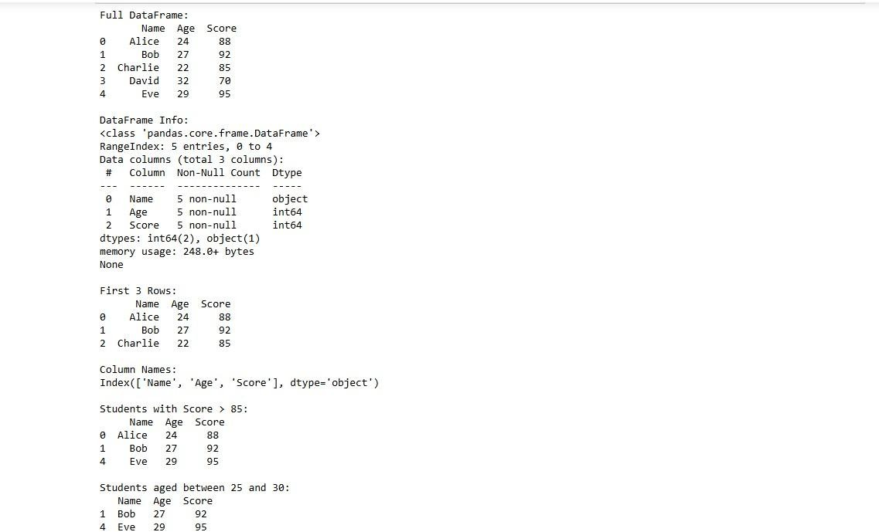

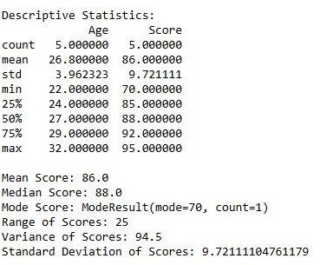

**Result:** Successfully inspected, filtered, and analyzed the dataset using Pandas and computed key descriptive statistics.